1. Describe standard swapping and its advantages.

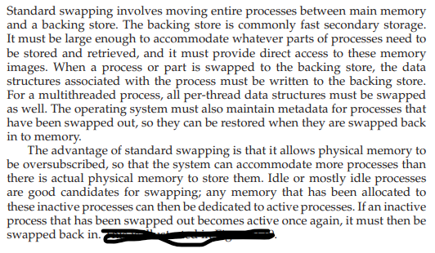

1. Describe necessary conditions which can rise deadlock situation in system.

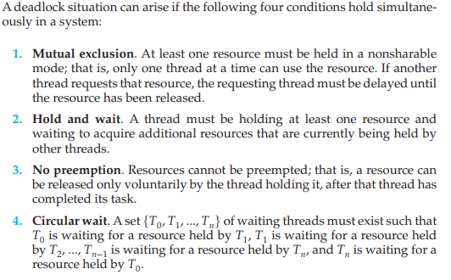

1. You are aware of dinning philosopher’s problem. Suppose we have $semaphore chopstick [5]$;

and all five philosophers become hungry at the same time and each grabs her left chopstick.

* 1. What is the value of chopstick now?
  2. What problem is going to take place when all philosophers would go to grab her right chopstick.
  3. If any problem, take place then give all possible remedies to avoid the problem.

Separate Quiz Paper:

1. Write a code for the following problem.

A student majoring in anthropology and minoring in computer science has embarked on a research project to see if African chimpanzees(chimps) can be taught about deadlocks. He locates a deep canyon and fastens a rope across it, so the chimpanzees can cross hand-over-hand. Several chimps can cross at the same time, provided that they are all going in the same direction. If eastward moving and westward moving chimps ever get onto the rope at the same time, a deadlock will result (the chimps will get stuck in the middle) because it is impossible for one chimps to climb over another one while suspended over the canyon. If a chimps wants to cross the canyon, it must check to see that no other chimp is currently crossing in the opposite direction. Write a program using semaphores that avoids deadlock. Do not worry about a series of eastward moving chimps holding up the westward moving chimps indefinitely.

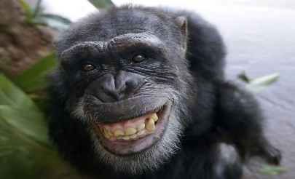

Solution:

